Name ______________________
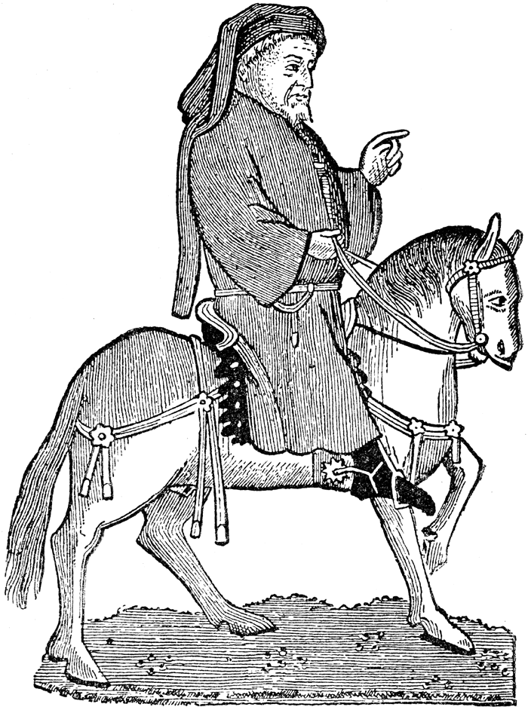
Chaucer Introduction to The Canterbury Tales
Day 1-2 Objective: To begin Chaucer’s Prologue by identifying the setting, characters and plot of the descriptive sketch of the period. All reading is found in Elements of Literature.
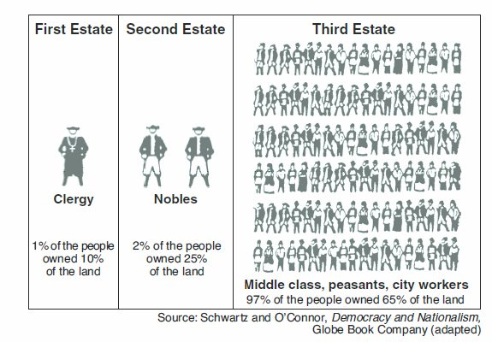
From Classwork on 11/9/16 (10 pts.)—Time and Author Facts
p. 113
Medieval Period or Dark Ages (?)
- Types of literature:
- Themes of literature:
p. 116-117
Geoffrey Chaucer (1343-1400)
- Occupations and influences:
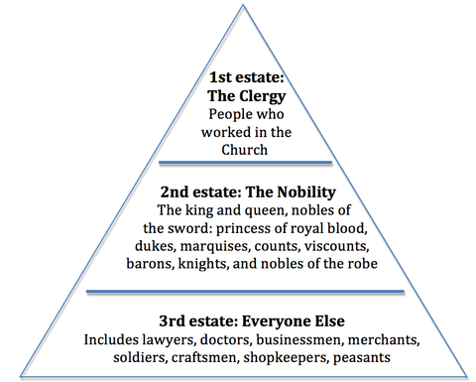
- Why the title “Father of English poetry”?
11/10/16
EL, p. 118-119—Background for The Canterbury Tales
- Who was Thomas a Becket?
- Why was Canterbury Cathedral a popular place to visit?
- What is a pilgrimage?
- What is the premise for The Canterbury Tales?
p. 121 What is a frame story?

p.120—Read and listen to the Middle English version of the prologue to The Canterbury Tales.
- Which words do you recognize as Modern English? (5-10 words)
- Which words are spelled or pronounced differently, but you can understand? (5-10 words)
p. 123 Read for narrative elements listed below.
Prologue Narrative Elements
Time of year:
Starting the journey where?
Destination:
Reason for the pilgrimage:
Mode of transport:
Number of pilgrims:
Plot—what will they do on the way?

