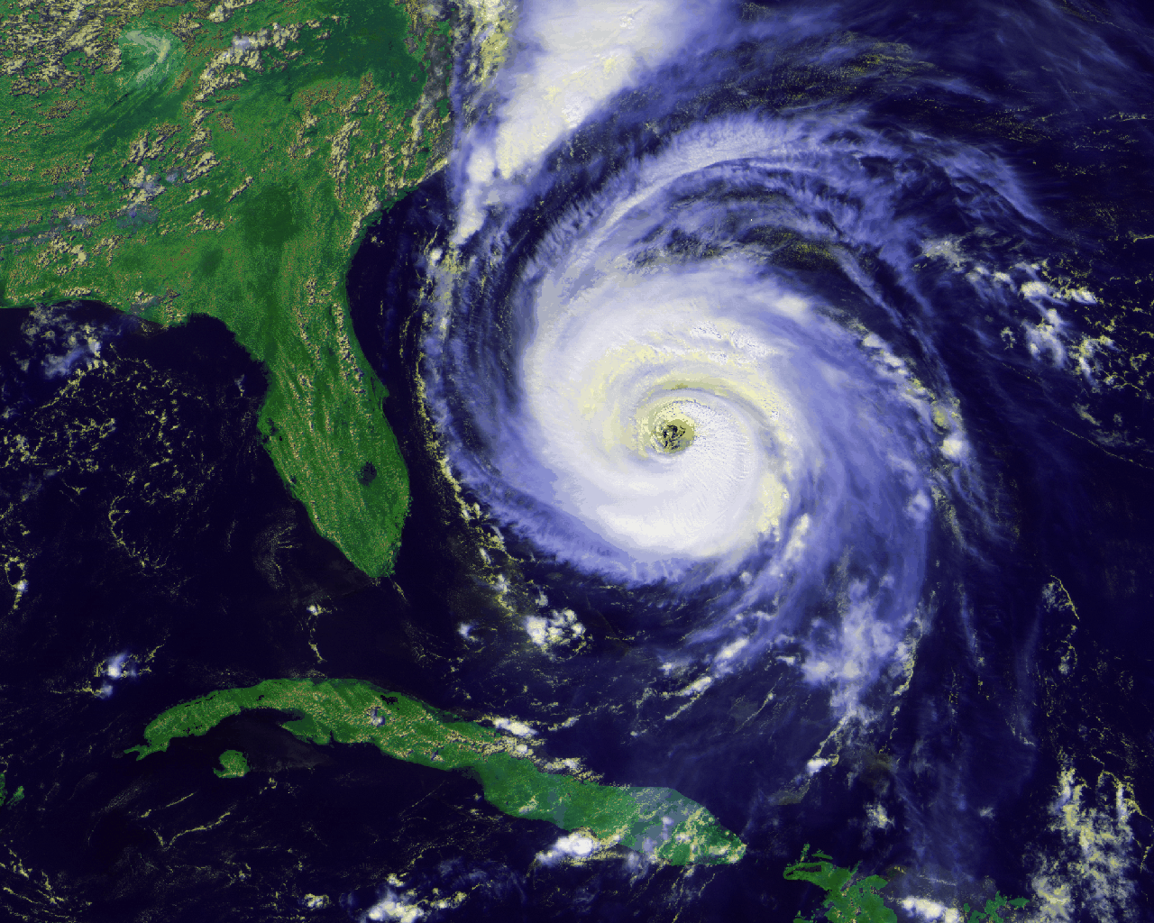
Handling Stress and Challenge Sept. 7, 2017 (Daily Writing #2)
Name __________________________________________
Objective: ____________________________________________________________________________
Warm up: When you research, what information is important to note about the source?

Class notes:
- Web source: 2. Print source:

- Interview:

- Modeling and identification: examine the citations then label each as a Web source, Print source or Interview.

- Beebe, Kyle. Interview. 6 June 2017.

- Popova, Maria. “A stoic’s key to peace of mind: Seneca on the antidote to anxiety.” Brain Pickings, Amazon Services, LLC, August 2017. https://www.brainpickings.org/2017/08/27/seneca-anxiety/?utm_source=Brain+Pickings&utm_campaign=2d7523cbd0-EMAIL_CAMPAIGN_2017_08_31&utm_medium=email&utm_term=0_179ffa2629-2d7523cbd0-236206817&mc_cid=2d7523cbd0&mc_eid=d843b1120c.

- Seneca. Campbell, Robin, trans. Letters from a Stoic. New York: Penguin Classics, 2015, 249-253.

- Class Discussion & Notes--Build a source citation for the article about preparing for a hurricane.

- Take note of the section you have been given from the article ____________________
- Read the portion you have and take notes from that section—think who, why, when, where, what and how.

- Compare your notes with another student who had the same portion. Add to your notes.

- Report to the class.

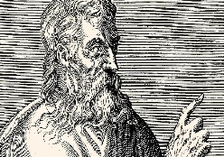
- Read the Brain Pickings article about worry. What advice does Seneca offer about worry and anxiety? Do you agree or disagree?

- How would Seneca view the preparations and media coverage of Hurricane Irma?

