Assignment: Analyze the Vice or Virtue of Chaucer’s Characters Name _____________
Use language of either chart to describe two of the characters in The Prologue to The Canterbury Tales.
We have read the Knight, the Squire, the Yeoman, the Prioress, the Monk, the Friar, the Merchant, the Oxford Cleric, the Lawyer, the Franklin, and the Cook.
Virtue | Meaning/Example | Vice | Meaning/Example
Humility |  | Pride
Generosity |  | Greed
Chastity |  | Lust
Patience |  | Wrath
Temperance |  | Gluttony
Kindness |  | Envy
Diligence |  | Slothfulness
Keep in mind the estate system that is eroding, the background you have from the class presentations, and Chaucer’s tone when presenting these characters.

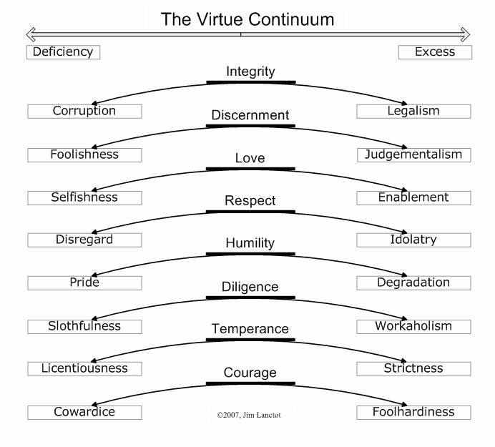

Model for Vice/Virtue Character Analysis
The Skipper
The Sailor/Skipper
There was a sailor, living far out west; 310
For aught I know, he was of Dartmouth town.
He sadly rode a hackney, in a gown,
Of thick rough cloth falling to the knee.
A dagger hanging on a cord had he
About his neck, and under arm, and down. 315
The summer's heat had burned his visage brown;
And certainly he was a good fellow.
Full many a draught of wine he'd drawn, I trow,
Of Bordeaux vintage, while the trader slept.
Nice conscience was a thing he never kept. 320
If that he fought and got the upper hand,
By water he sent them home to every land.
But as for craft, to reckon well his tides,
His currents and the dangerous watersides,
His harbours, and his moon, his pilotage, 325
There was none such from Hull to far Carthage.
Hardy. and wise in all things undertaken,
By many a tempest had his beard been shaken.
He knew well all the havens, as they were,
From Gottland to the Cape of Finisterre, 330
And every creek in Brittany and Spain;
His vessel had been christened Madeleine.

Model Analysis
Chaucer’s sailor or skipper should be a third estate character who barely fits into the diverse collection of pilgrims. As a sailor, his status would b below the merchant because he would be responsible for ferrying a merchants goods, and he would also be below the yeoman because that pilgrim is in service to a knight and his squire. Most sailors at the time were tricked or shanghaied into work on ships and rarely set foot on land during their service. They were more like indentured servants than free agents like we think of sailors today. He is most closely related in status to the serf/peasant character of the plowman, but there the similarities end. Where the plowman is humble and noble in his devotion to the land, the sailor is morally corrupt.
The description of the sailor mentions that he rides “sadly” on a “hackney” in line 312. A hackney was a farmer’s horse. Later hackney carriages were ones that could be cheaply hired, but the medieval reader might wonder where he obtained his horse. His clothing is out of place in the parade of finely dressed guildsmen and intellectuals—he wears a robe of rough cloth that falls to his knees with a dagger visible as he wears it slung across is chest o a cord in lines312-315. He is deeply tanned like the yeoman (l. 316), but he contrasts the noble yeoman in the next few lines where it is revealed that he drinks the wine on the ship while the the trader or guard sleeps (l. 318-319). In fact, the narrator states his conclusion aloud—“Nice conscience was a thing he never kept”(l. 320) which means the sailor has no guilt when he steals from the ship’s contents.
The sailor is also revealed to be a cutthroat with those who try to steal from him—the insinuation in lines 321-322 is he would force his enemies to walk the plank—which is not generous or patient. That practice was frowned upon by the end of the Middle Ages although public hangings and punishments were the norm at the time. For the rest of the description, there is a testament to the sailors’s diligence concerning his knowledge of ports, the sea passages, along with dangers of certain ports. In fact, the lines 323-332 are loaded with admiration of his skills and knowledge.
The description of the sailor is a mixture of condemnation and guarded respect. The man is good at what he does—this diligence to his occupation—but there is a thread of moral corruption or greed as he steals from his clients, and then capital vice as he is ruthless with his enemies. His sadness adds to a general conclusion that he is not satisfied with his way of life. That sadness might have led to his choice to join the pilgrimage.
