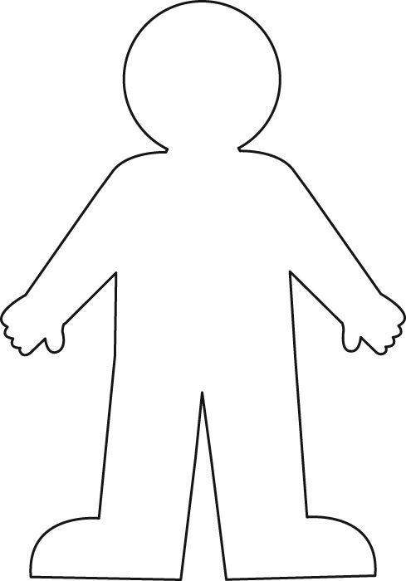
Character’s name __________________________________

Psychology of the character:
________________________________________ Physiology of the character:
______________________________ ________________________________
____________________________ ________________________________
_______________________________ __________________________________
______________________________ ______________________________

Sociology of the character: ______________________________________________________________
_____________________________________________________________________________________
_____________________________________________________________________________________
_____________________________________________________________________________________

Use quotes and inferences you can make from the quotes. Be sure to note the page number where the note appeared in the story. If needed, add additional lines to each section.

