Expository Writing
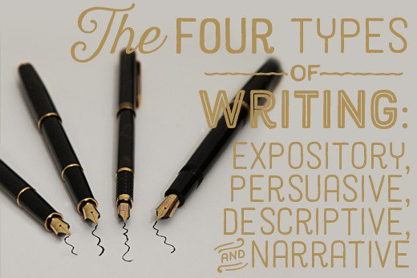
Expository writing explains or informs. It talks about a subject without giving opinions." title="Expository writing explains or informs. It talks about a subject without giving opinions."/>
Expository writing explains or informs. It talks about a subject without giving opinions.
Expository writing's main purpose is to explain. It is a subject-oriented writing style, in which authors focus on telling you about a given topic or subject without voicing their personal opinions. These types of essays or articles furnish you with relevant facts and figures but do not include their opinions. This is one of the most common types of writing. You always see it in textbooks and how-to articles. The author just tells you about a given subject, such as how to do something.
Types of Organization:
- Compare or contrast
- Cause and effect
- Problem and solution
- How-to process
- Chronological discussion
Key Points:
- Usually explains something in a process.
- Is often equipped with facts and figures.
- Is usually in a logical order and sequence.
When You Would Use Expository Writing:
- Textbook writing.
- How-to articles.
- Recipes.
- News stories (not including opinion or editorial pieces).
- Business, technical, or scientific writing.

The difference between expository and argumentative
Example:
Many people associate the taste of pumpkins with fall. In October, companies from Starbucks to McDonalds roll out their pumpkin-flavored lattes and desserts. Here is how to make an easy pumpkin pie using only five ingredients. First, make sure you have all of the ingredients.
This writing is expository because it is explaining. In this case, you can already tell that the piece will be about how to make a pumpkin pie.
Non-example:
Everyone knows that the best part about fall is all of the pumpkin-flavored desserts. Pumpkin pie is the best fall treat because it is not only delicious but also nutritious. Pumpkin is filled with vitamin A, which is essential for a healthy immune system and good vision.
This is not expository because several opinions are stated, such as “Pumpkin pie is the best fall treat…” Although this excerpt contains a fact about pumpkin containing vitamin A, that fact is used as evidence to support the opinion. These opinions make this an example of persuasive writing.
After you decide how to approach your topic, create an outline of your essay.
Assignment: Create an outline for your expository or informational essay about your research topic.
- Step 1—make a list of topics you read about
- Step 2—decide why someone is likely to read about your topic—this turns into your thesis
- Step 3—decide how you will capture the reader’s attention—this becomes your attention grabber
- Step 4—quickly create your outline with subject headings:
  - Introduction and thesis
  - Body—the main points and the details you gathered
  - Conclusion—overall summary, cycle back to the thesis, and perhaps speculate on further research needed

If you use this outline as a template, save as your topic name and outline—“ghosts outline” then write over each line.

Outline for Ebola

I. Introduction and Thesis
a. Attention-grabber: vignette about NYC doctor feverish with Ebola, traveling through NYC.
b. Thesis: The contagious nature of Ebola should be respected by everyone despite cultural habits
and traditions.
c. Outline of the essay
1. What is Ebola and how is it transmitted?
2. West African culture contributes to spread of the disease
a. Death and burial customs
b. Traditional treatment of illness
4. American culture contributes to the spread of the disease
a. Freedom of movement
b. Failure of trust
6. Solutions
II. Body
a. What is Ebola and how is it transmitted?
b. West African death and burial customs
c. West African treatment of illness
d. American freedom of movement
e. Failure of trust
f. Solutions to the mismatch between culture and treatment.

III. The Conclusion
a. Tell the end of the NYC doctor story
b. Summarize the key points of the essay
c. Call to action or a quote about epidemics

so . . .
The basic outline is the essay in skeleton form. Some writers make another copy of the outline, save as “Draft” and write the paragraphs right into the outline including the text support from research.
Ex.
I. Introduction and Thesis
a. Attention-grabber: When Harry Franklin returned from Cote’d Ivoire for holidays with his family, he had no idea that he was bringing his family the dubious gift of Ebola. He remembers feeling feverish while waiting to board the plane to New York, but he didn’t think anything of it. “Everybody thinks they are invincible,” he said from his bed in quarantine. He remembers coughing in the taxi after he left LaGuardia Airport, seeing blood on his handkerchief, and the suspicious look on the cabbie’s face. The driver dropped Franklin at his home on the Upper East side and drove away without the fare. (Bestgate).
b. Thesis: The contagious nature of Ebola should be respected by everyone despite cultural habits
and traditions.
c. Outline of the essay
1. What is Ebola and how is it transmitted?
2. West African culture contributes to spread of the disease
a. Death and burial customs
b. Traditional treatment of illness
4. American culture contributes to the spread of the disease
a. Freedom of movement
b. Failure of trust
6. Solutions

