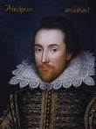
Macbeth Resources
www.sparknotes.com. Search the act and the character
www.hhshakespeare-navigator.com The entire text online
www.Shakespeare-online.com Good summaries and discussions
www.folger.edu/template.cfm?cid=2778 Teaching Macbeth-Folger Shakespeare Library
www.shmoop.com › Literature Macbeth – Shmoop—a bit irreverent but easy to understand

