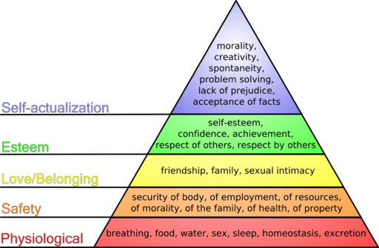
The Car by Gary Paulsen Name __________________________

Maslow’s Hierarchy of Needs

After reading Chapters 1 and 2, create a hierarchy of needs pyramid for Terry Anders in your reading journal.

