Open Note Review/Quiz
Macbeth Act I
- By the end of Act I, Scene 3, Banquo Macbeth that the witches are “instruments of darkness” and refers to them as devils (“Can the Devil speak true?”). Explain what you understand about the role of the witches in the play so far.
- Macbeth is portrayed as a war hero by the bleeding captain. In Scene 5, Macbeth’s wife will worry that he is “too full of the milk of human kindness” to be cruel enough to take the throne from Duncan. What does the audience know about Macbeth through the battle reports, his meeting with the witches, his discussions with Banquo and his own thoughts revealed in the asides (end of Scene 3 and 4)?
- Lady Macbeth is always portrayed as a beautiful, devoted wife waiting for her husband to return from the civil war. How is her appearance deceptive? (Use her soliloquy in Act I, Scene 5 for evidence.)
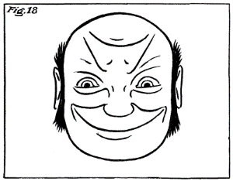
Another approach—In Act I, Scene 4 King Duncan laments, “There’s no art in finding the mind’s construction in the face; he was a man in whom I had absolute trust.” Duncan realizes that he cannot judge a book by its cover. How is that true about the characters in the play? Paraphrase and quote to characterize the two sides of each character.

