Seminar 3-- Communication 2, Legal Issues in the Workplace, Career Planning 1
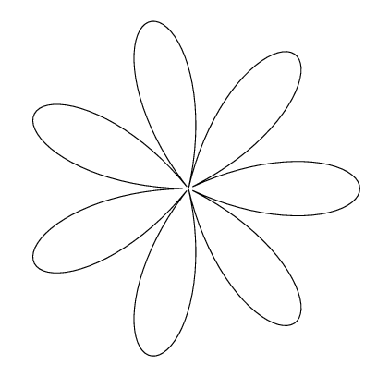
Reflection Journal # 3

Where did you work? ___________________________

Describe the job(s) you did at that workplace.
______________________________________________________________________________________________________________________________________________________________________________________________________________________________________________________________________________________________________________________________________________________________

Who did you work with most of the time? Describe that person.
______________________________________________________________________________________________________________________________________________________________________________________________________________________________________________________________________________________________________________________________________________________________

What was the easiest part of the job?

What was the most challenging?

Offer a piece of advice to another student starting the same job:

We discussed workplace safety during Seminar 2. Describe the safety measures used at your workplace.
Reflecting on your work experience:
Match the Personal Traits with the best descriptor:
Friendliness, enthusiasm, adaptability, and respect for others

Self-control

Confidence

Loyalty and trustworthiness

Dependability and positive motivation

The ability to say and do things in a respectful way
Responsibility

Self-Esteem

Sociability

Self-Management

Tact

Integrity and Honesty

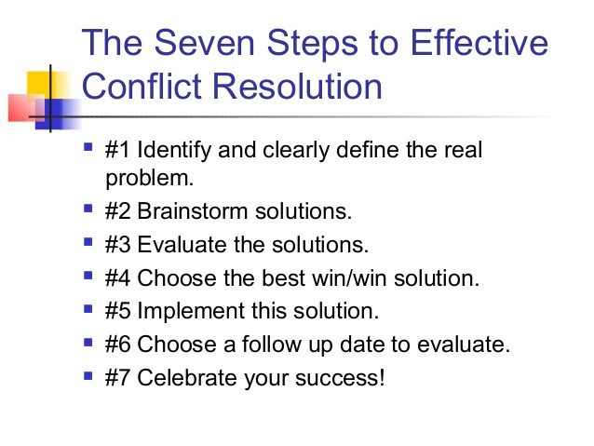
The Circle of Conflicts

