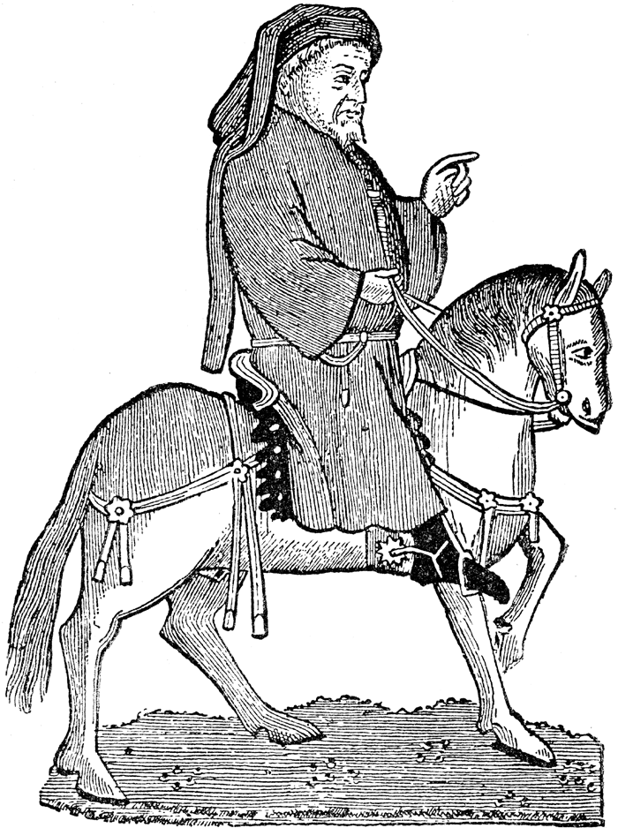
Middle Ages Project—Work Nov. 15, 19, 20 Present 11/26-28
Objective: To practice speaking and listening skills. To prepare for reading Chaucer’s Canterbury Tales, research to explain one aspect of life during the Middle Ages in England.
Assignment:
- Explore the topic using the sources offered on www. jdcooper.weebly.com.
- Decide what information you want to share with the class—try for 5 salient points.
- Create a slide show (PowerPoint, Prezi, or Smart) that offers pictures and captions. Include the link to the web page or reference to the print source used.
- Practice a class presentation with your team. Group work 25 pts.
- Present the topic to your class—3 min max
--50 pts.
- Individual outline of presented information-25 pts.
Topics:
Clothing styles and fashions
Education/schools/literature
Games and other Entertainment
Medicine/Plague
The Church and its clergy
Food and diet
Money, property, and finance
Guilds/occupations
Travel
Town Life
Life of a noble
Suggested Sources:
Clergy in the Middle Ages—The Finer Times
Life in the Middle Ages British Library
Annenberg Learner Feudal Life
History on the Net—Good for every topic
The British Express—Time Period Goodies
BBC--Bitesize Learning--Life during the Middle Ages
The Middle Ages for Kids—get over the title and use it.
Video on Serf Life by Terry Jones—of Monty Python fame
Glossary of Medieval Church

Knights and chivalry
Knights and weaponry
Hunting and weapons
Crime and punishment
Law
The Magna Carta
Inventions

